

RESERVE BANK OF INDIA REPORT

Submitted by
Kanokphan Sirithienthong (Student ID: 6610750092),
Faculty of Economics (English Program),
Kasetsart University Bangkhen Campus

Submitted to
Assoc.Prof.Attasuda LERSKULLAWAT, Ph.D,
01101384 Economics of Money and Banking Section 415

Date
9th September, 2025

Table of Contents

Chapter 1: History

1.1 Origins of Central Banking in India

1.2 Establishment of the RBI

1.3 Post-Independence Transformation

1.4 Regulatory Expansion and Reform

1.5 Inflation Targeting and Digital Innovation

Chapter 2: Functions, Aims and Monetary Role

2.1 Core Functions of the RBI

2.2 Monetary Policy Tools

2.3 Currency Issuance and Liquidity Management

2.4 Inflation Targeting Framework

2.5 Digital Currency and Financial Inclusion

Chapter 3: Cooperation with Other Institutions

3.1 Domestic Partnerships

3.2 International Engagements

3.3 Regional Leadership and SAARCFINANCE

3.4 Fintech Oversight and Digital Regulation

Chapter 4: Summary

4.1 Institutional Evolution

4.2 Strategic Priorities

4.3 Future Challenges and Opportunities

References

Chapter 1: History
The development of the Reserve Bank of India (RBI) reflects the broader changes in India’s economy and political system. Before the RBI was created, India’s banking system was shaped by three Presidency Banks, Bombay (1840), Calcutta (1806), and Madras (1843). These banks were set up during British colonial rule and mainly served regional trade and government treasury needs. In 1921, they were merged to form the Imperial Bank of India. This bank acted like a semi-central bank, managing government accounts and offering limited credit, but it did not have full control over the country’s money supply or credit system.
As global financial instability increased, especially after the Great Depression, it became clear that India needed a central bank with stronger powers. In 1926, the Hilton Young Commission was formed to study the issue. The commission recommended creating a central bank to manage currency, regulate credit, and support economic growth. Based on this advice, the Reserve Bank of India Act was passed in 1934. The RBI officially started its operations on April 1, 1935.
At first, the RBI was privately owned. But after India gained independence in 1947, the bank was nationalized in 1949. This change marked a major shift toward government-led monetary policy. The RBI’s goals were now aligned with national development plans. In the early years of independence, the RBI played a key role in supporting the Five-Year Plans. It helped direct credit to important sectors like agriculture, small industries, and infrastructure. To do this, the RBI used tools such as selective credit controls, fixed interest rates, and special refinancing schemes. It also helped expand banking in rural areas by licensing new branches and supporting the creation of regional rural banks.
In the 1970s and 1980s, the RBI’s role as a regulator grew stronger. It introduced rules for priority sector lending, improved supervision of cooperative banks, and began publishing guidelines for classifying assets and setting aside provisions for bad loans. However, the banking system was still highly controlled, with little competition and weak financial performance. In 1991, India faced a serious balance-of-payments crisis. This led to major economic reforms, and the RBI began to adopt more market-friendly policies and gained more independence. The Narasimham Committee reports of 1991 and 1998 suggested several important changes, such as better capital rules, stronger monetary policy tools, and the creation of an independent office to manage government debt.
After these reforms, the RBI moved toward a more transparent and rule-based approach to monetary policy. In 2016, the Monetary Policy Committee (MPC) was introduced to set interest rates and manage inflation. The RBI was given a formal target to keep consumer price inflation at 4 percent, with a tolerance range of ±2 percent. This was a major change from earlier methods, which were more flexible and less predictable. The RBI also embraced new technologies, launching systems like NEFT (National Electronic Funds Transfer), RTGS (Real-Time Gross Settlement), and UPI (Unified Payments Interface), which transformed digital payments in India. In 2022, the RBI started pilot programs for the digital rupee (e-₹), testing features like programmable money, offline payments, and smart contracts. These steps show how the RBI continues to evolve as both a monetary authority and a leader in financial innovation.
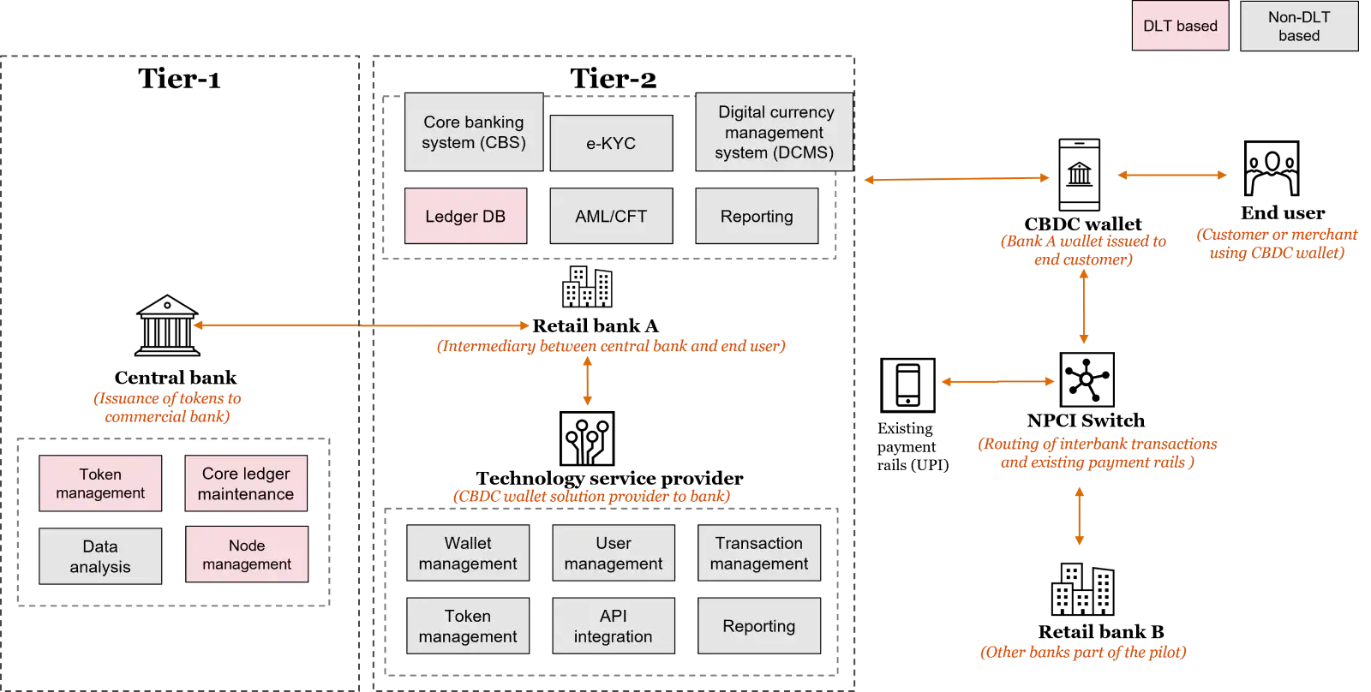
Reference: End-to-end architecture for the digital rupee pilot, PwC India

Chapter 2: Functions, Aims and Monetary Role
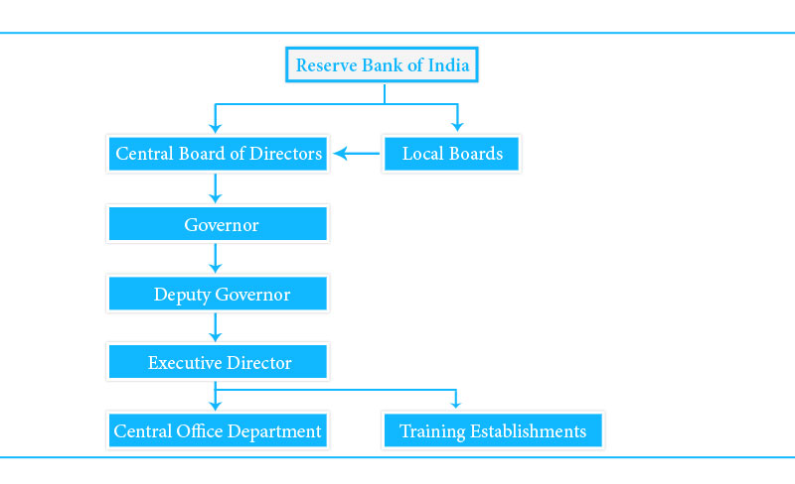

Reference: Organizational Structure, Splessons
The Reserve Bank of India (RBI) has many important roles that help support India’s economy. It is responsible for managing monetary policy, regulating financial institutions, issuing currency, and supporting development goals. One of its key functions is acting as the banker to both the central and state governments. This means the RBI manages government accounts, helps issue public debt, and provides short-term financial support through a system called Ways and Means Advances. It also organizes auctions for treasury bills and government bonds, which helps the government raise money in a stable and planned way. The RBI works closely with the Ministry of Finance and the Controller General of Accounts to make sure government cash flows are managed properly.
The RBI also acts as the banker to commercial banks. It provides liquidity to the banking system through the Liquidity Adjustment Facility (LAF), which includes repo and reverse repo operations. These tools help control short-term interest rates and ensure that banks have enough funds to operate smoothly. In addition, the RBI offers standing facilities like the Marginal Standing Facility (MSF) and the Standing Deposit Facility (SDF), which allow banks to borrow or deposit money overnight. These tools are important for keeping the interbank market stable and for making sure monetary policy decisions are passed on effectively. During times of financial stress, the RBI also acts as the lender of last resort, offering emergency funds to banks that are facing serious problems.
Another major responsibility of the RBI is issuing currency. It is the only institution in India allowed to print and circulate banknotes. The RBI works with the Security Printing and Minting Corporation of India to produce currency and make sure it is safe and reliable. It uses anti-counterfeiting technology, updates the design of notes when needed, and removes damaged notes from circulation. The RBI also manages how currency is distributed across the country, using a network of currency chests operated by commercial banks.
As a regulator, the RBI supervises commercial banks, non-bank financial companies (NBFCs), cooperative banks, and payment system operators. It sets rules for capital adequacy, asset classification, and loan provisioning. The RBI carries out inspections, monitors financial data, and performs stress tests to check for risks in the system. Twice a year, it publishes the Financial Stability Report, which gives a detailed view of the health of India’s financial system and explains how the RBI is responding to any problems.
The RBI’s goals are broad and reflect its dual mandate: price stability and economic development. Its inflation-targeting framework is designed to keep consumer price inflation around 4 percent, with a tolerance range of ±2 percent. At the same time, the RBI supports growth by making sure credit reaches important sectors like agriculture, small businesses, and housing. It helps create jobs by offering refinancing schemes, interest support programs, and liquidity assistance to micro, small, and medium enterprises (MSMEs). The RBI also promotes financial inclusion through programs like Jan Dhan Yojana, Aadhaar-linked payment systems, and small-value credit options. To protect India’s external position, the RBI manages foreign exchange reserves, monitors capital account openness, and works with global financial institutions.
To carry out its responsibilities, the RBI uses a wide range of monetary policy tools. Conventional tools include the repo rate, reverse repo rate, bank rate, and reserve ratios like the Cash Reserve Ratio (CRR) and Statutory Liquidity Ratio (SLR). These tools affect short-term interest rates, liquidity levels, and how much credit is available in the economy. The RBI also uses Open Market Operations (OMO) to buy or sell government securities, which helps control the amount of money in the system. It conducts term repos and variable rate auctions to fine-tune liquidity when needed.
In recent years, the RBI has also used unconventional tools to deal with special situations. For example, during the COVID-19 pandemic, it introduced Targeted Long-Term Repo Operations (TLTRO) to provide liquidity to specific sectors like NBFCs, housing finance companies, and corporate bonds. Operation Twist is another tool that involves buying long-term government securities and selling short-term ones to influence interest rates across different time periods. The Market Stabilization Scheme (MSS) allows the RBI to absorb extra liquidity by issuing special bonds, especially when there are large capital inflows. The digital rupee pilot is a new step in innovation, exploring the use of programmable money, offline transactions, and smart contracts. These tools show how the RBI is adapting to changing economic conditions and using new methods to support stability and growth.

Chapter 3: Cooperation with Other Institutions
The Reserve Bank of India (RBI) works with a wide network of domestic and international institutions to strengthen policy coordination, financial stability, and technological innovation. Domestically, it collaborates with the Ministry of Finance through the Financial Stability and Development Council (FSDC) to align fiscal and monetary strategies, especially during periods of economic stress. It also works with the Controller General of Accounts to manage government cash flows and debt servicing. Regulatory coordination is maintained through partnerships with SEBI, IRDAI, and PFRDA, ensuring consistent oversight across capital markets, insurance, and pensions.
The RBI plays a central role in India’s digital payment ecosystem by supervising the National Payments Corporation of India (NPCI), which operates platforms like UPI and IMPS. It also engages with fintech firms, payment service providers, and cybersecurity agencies to promote safe and inclusive financial innovation. In the digital space, the RBI partners with MeitY, UIDAI, and the Data Protection Authority to uphold privacy and security standards.
Internationally, the RBI maintains currency swap agreements with central banks such as Japan and the UAE, and participates in the IMF’s Special Drawing Rights (SDR) program to support global liquidity. It leads regional cooperation through SAARCFINANCE, promoting shared training, policy dialogue, and financial integration across South Asia.
As a member of the Bank for International Settlements (BIS), the RBI contributes to global committees including the CPMI, BCBS, and the Financial Stability Board. These platforms help India adopt international standards such as Basel III, improve risk management, and monitor systemic vulnerabilities. Through these partnerships, the RBI ensures that India’s financial system remains resilient, well-regulated, and globally connected.

Chapter 4: Summary
The Reserve Bank of India (RBI) has grown from a colonial-era institution into a modern central bank that plays a key role in India’s economy. Over the years, it has adapted its responsibilities, tools, and partnerships to meet the changing needs of the country. Its core functions, such as issuing currency, regulating banks, and managing government finances, have expanded to include financial stability, digital innovation, and international cooperation.
The RBI’s monetary policy has become more structured and transparent. It moved from using credit controls to adopting a formal inflation-targeting system. This change has helped build trust in the RBI’s decisions and made its goals clearer to the public. The creation of the Monetary Policy Committee has also improved how interest rates are set, making the process more accountable. At the same time, the RBI has shown flexibility by using special tools like TLTROs, Operation Twist, and the Market Stabilization Scheme to deal with specific challenges and economic shocks.
Its role as a regulator has also become stronger. The RBI now focuses more on risk management, financial safety, and protecting consumers. It supervises banks, non-bank financial companies, and payment systems to make sure they follow rules and operate safely. The RBI also supports financial inclusion by helping expand access to banking services, digital payments, and microfinance. These efforts have helped millions of people join the formal financial system and improved economic opportunities across the country.
The RBI works with many partners, both inside India and around the world. It coordinates with government ministries, financial regulators, and payment system operators to keep policies aligned and respond to problems quickly. It also takes part in global discussions through organizations like the IMF and BIS, helping shape international financial rules and sharing knowledge. Its leadership in regional groups like SAARCFINANCE shows its commitment to building strong financial systems across South Asia.
Looking ahead, the RBI faces new challenges and opportunities. The launch of the digital rupee brings questions about privacy, technology, and how money will work in the future. Climate finance is becoming more important, and the RBI will need to include environmental risks in its policies. As global capital flows, fintech innovations, and cyber threats become more complex, the RBI must stay flexible and ready to act.
In conclusion, the RBI is more than just a central bank, it is a key partner in India’s development, a strong regulator, and an active member of the global financial community. Its ability to balance stability with innovation, independence with cooperation, and national goals with international standards will shape India’s financial future. As the economy continues to grow and change, the RBI’s leadership and adaptability will remain essential.

References

Chapter 1: History
- Reserve Bank of India. History of the RBI. Retrieved from https://rbi.org.in/scripts/Project1.aspx
- Scribd. (1991). Narasimham Committee Report I. Retrieved from https://www.scribd.com/doc/66968519/Narasimham-Committee-Recommendations-1991
- Enablers India. (1998). Narasimham Committee Report II. Retrieved from https://www.enablersindia.com/banker/ibfsa10.pdf
- Reserve Bank of India. (1931). Hilton Young Commission Report. Retrieved from https://rbi.org.in/scripts/PublicationReportDetails.aspx?ID=367
- Reserve Bank of India. (2025). RBI Annual Report 2024–25, Historical Overview Section. Retrieved from https://rbi.org.in/Scripts/AnnualReportPublications.aspx
- PwC India. (2024). Future of digital currency in India. Retrieved from https://www.pwc.in/research-and-insights-hub/future-of-digital-currency-in-india.html

Chapter 2: Functions, Aims and Monetary Role
- Reserve Bank of India. (2016, October). Monetary Policy Report. Retrieved from https://rbi.org.in/Scripts/PublicationsView.aspx?id=17665
- Reserve Bank of India. (2023). Handbook of Statistics on Indian Economy. Retrieved from https://rbi.org.in/Scripts/AnnualPublications.aspx?head=Handbook%20of%20Statistics%20on%20Indian%20
- Economy Reserve Bank of India. (2024, June). Financial Stability Report. Retrieved from https://rbi.org.in/Scripts/PublicationReportDetails.aspx?ID=1255
- Reserve Bank of India. Circulars on CRR/SLR and MSF Operations. Retrieved from https://rbi.org.in/Scripts/BS_ViewCirculars.aspx
- Reserve Bank of India. (2022). Digital Currency Pilot Overview. Retrieved from https://rbi.org.in/Scripts/BS_PressReleaseDisplay.aspx?prid=54645
- National Payments Corporation of India. (2024). UPI Transaction Data. Retrieved from https://www.npci.org.in/what-we-do/upi/product-statistics
- SPLessons. Reserve Bank of India. Retrieved from https://splessons.com/lesson/reserve-bank-of-india/

Chapter 3: Cooperation with Other Institutions
- Ministry of Finance. Financial Stability and Development Council Reports. Retrieved from https://dea.gov.in/fsdc
- Securities and Exchange Board of India. (2024). Annual Report 2023–24. Retrieved from https://www.sebi.gov.in/sebiweb/home/HomeAction.do?doListing=yes&sid=3&smid=0
- National Payments Corporation of India. (2024). Annual Review. Retrieved from https://www.npci.org.in/annual-review
- International Monetary Fund. (2024, March 15). India: Selected Issues. Country Report No. 24/112. Retrieved from https://www.imf.org/en/Publications/CR/Issues/2024/03/15/India-Selected-Issues-537891
- SAARCFINANCE. (2023). Regional Cooperation Updates. Retrieved from https://saarcfinance.org
- Bank for International Settlements. (2022). National Payment Systems in India. CPMI Reports. Retrieved from https://www.bis.org/cpmi/publ/d213.htm

Chapter 4: Summary
- Reserve Bank of India. (2023–2025). Governor Speeches. Retrieved from https://rbi.org.in/Scripts/BS_SpeechesView.aspx
- Reserve Bank of India. (2025). Vision Document for 2025. Retrieved from https://rbi.org.in/Scripts/PublicationVisionDocuments.aspx
- Bank for International Settlements. Innovation Hub Reports on Digital Currency. Retrieved from https://www.bis.org/about/bisih/topics/cbdc.htm
- International Monetary Fund. (2024, April 11). Global Financial Stability Report, April 2024. Retrieved from https://www.imf.org/en/Publications/GFSR/Issues/2024/04/11/global-financial-stability-report-april-2024
- World Bank. (2023). India Financial Sector Assessment. Retrieved from https://documents.worldbank.org/en/publication/documents-reports/documentdetail/099345001072318741

